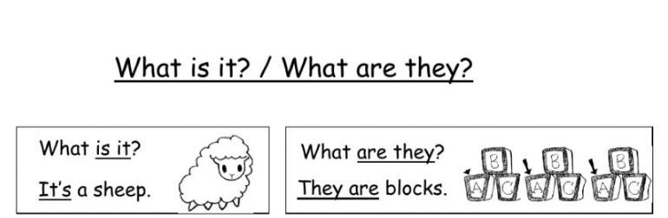

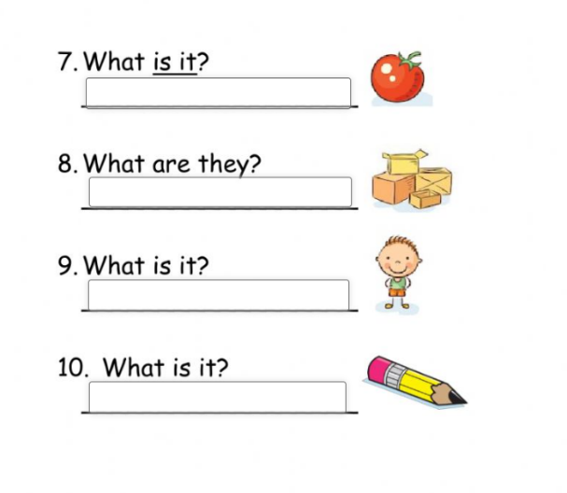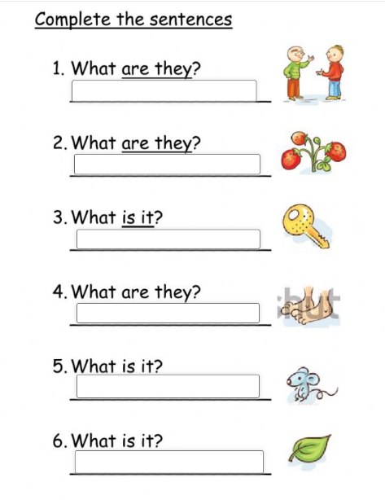

It is a pencil.

It is a boy.

They are boxes.

It is an apple.

It is a leave.

It is a mouse.

They are feets.

It is a key.

They are strawberries.

They are boys.