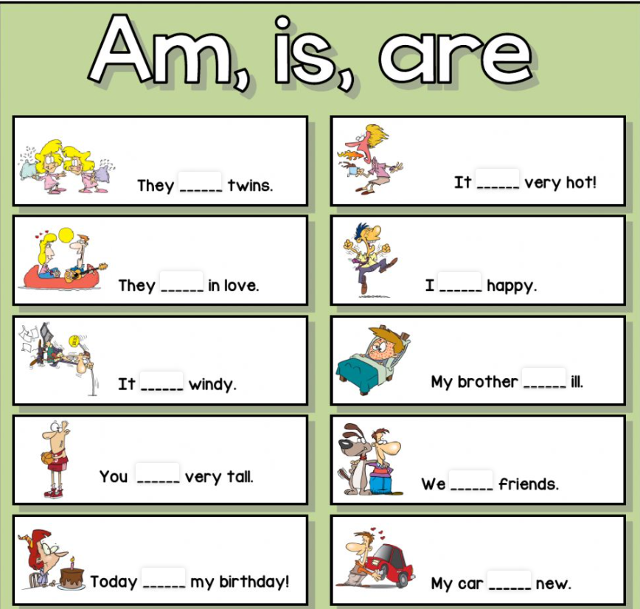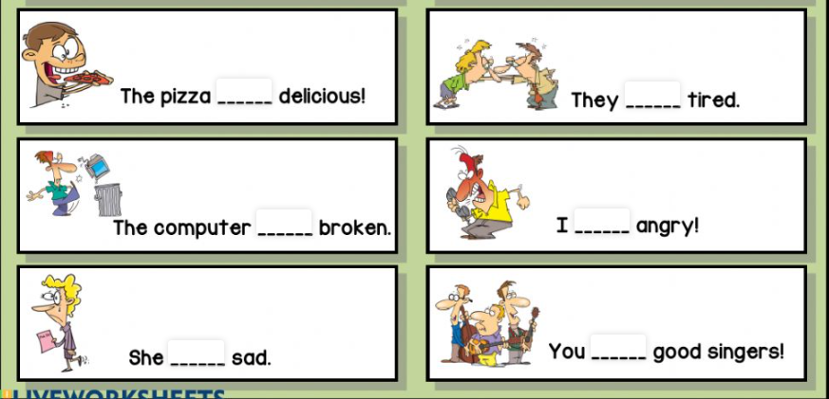

is

is

is

is

is

is

is

is

am

am

are

are

are

are

are

are